**Project Report**

**SKY ROAMER(Travel)**

**AJ_Project49**

**BRD-218**

Project Members

* Nidhi Sharma(761492)
* Sanchit Ram Nayan Patel(761482)
* Surbhi Jain(761388)
* Tejashree Maharana(761489)

**Landing Page using particles.js animation**



When you click at “About”, it will redirect you to

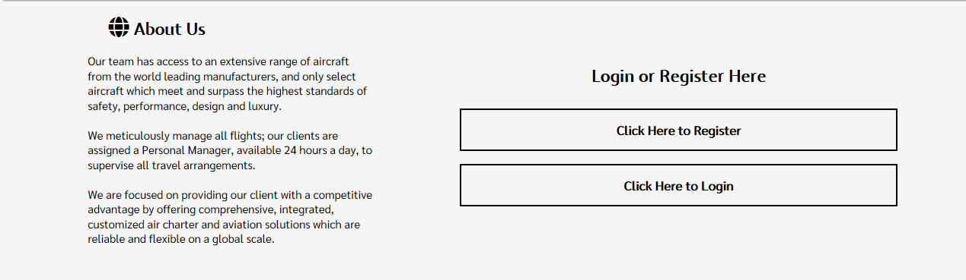

When you click at “Services”, it will redirect you to

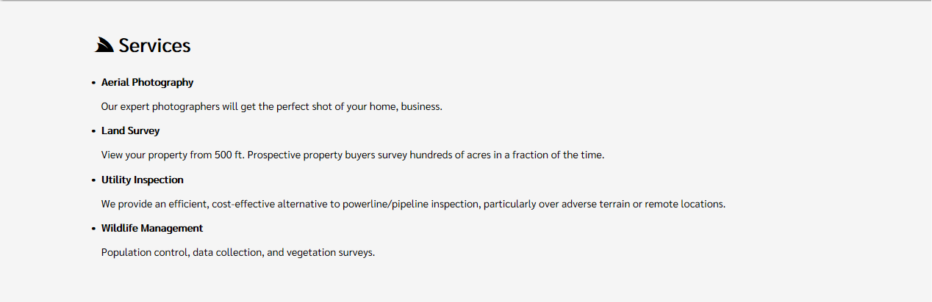

When you click at “Helicopters”, it will redirect you to

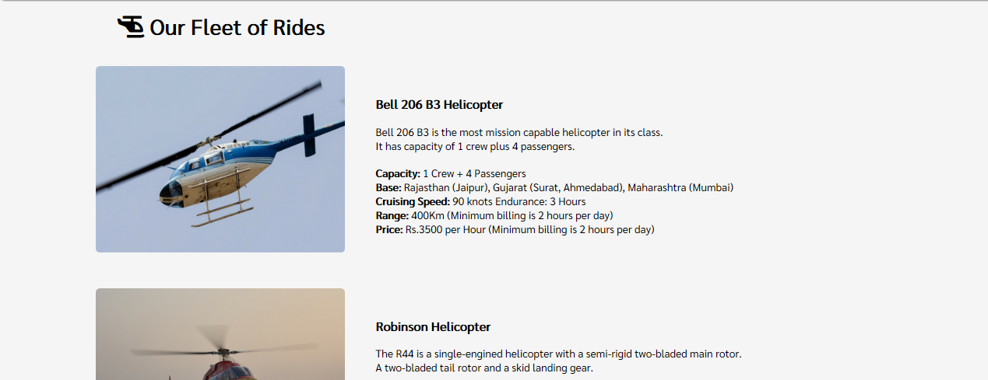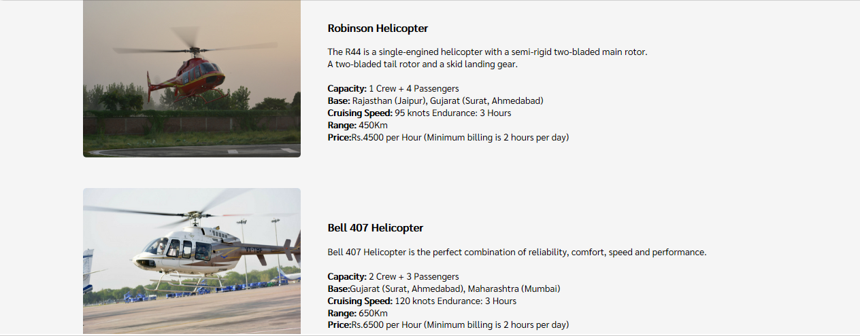

When you click at “FAQs”, it will redirect you to

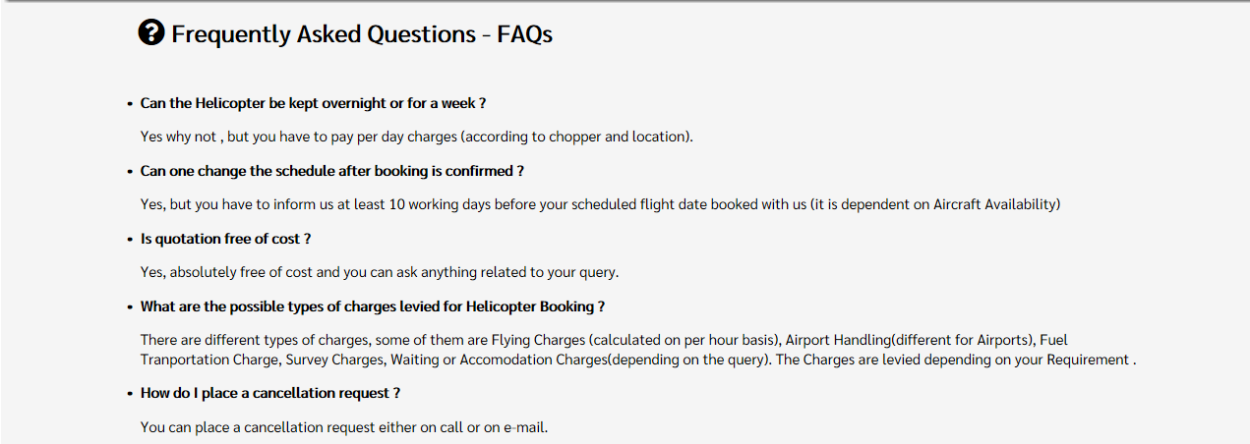

When you click at “Contact”, it will redirect you to



When you click at “Book Your Trip Here”, it will redirect you to

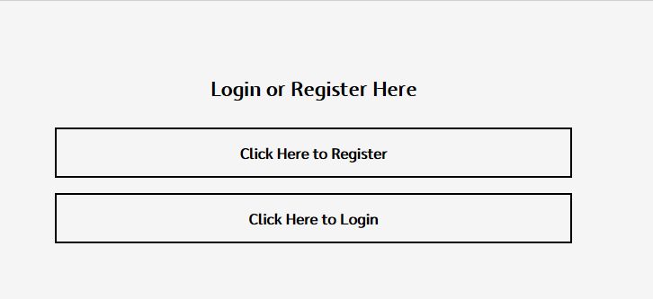

When you click at “Click Here to Register”, it will redirect you to

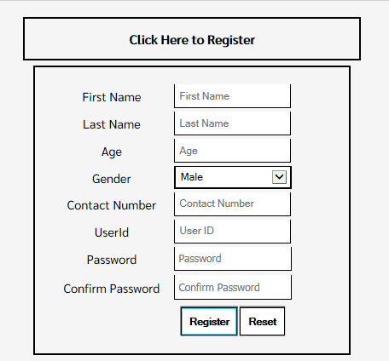

When you click at “Click here to Login”, it will redirect you to

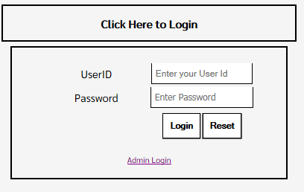

When you click at “Admin Login”, it will redirect you to

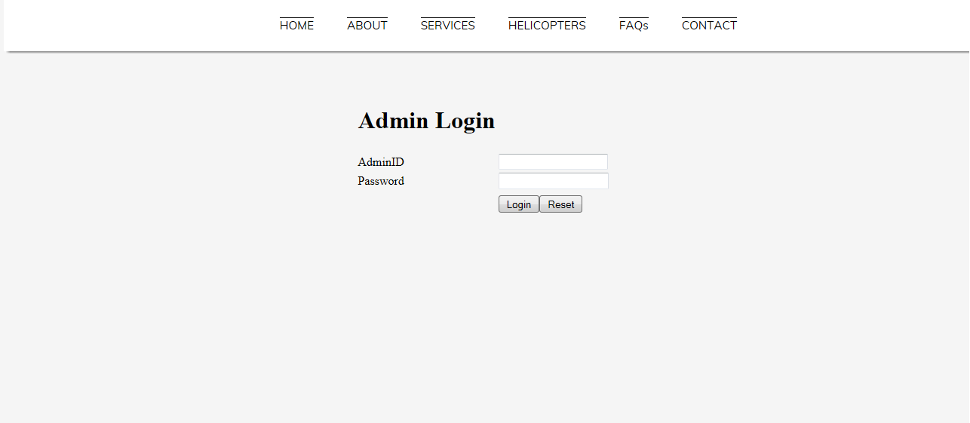

When admin click at “Login”, it will redirect you to 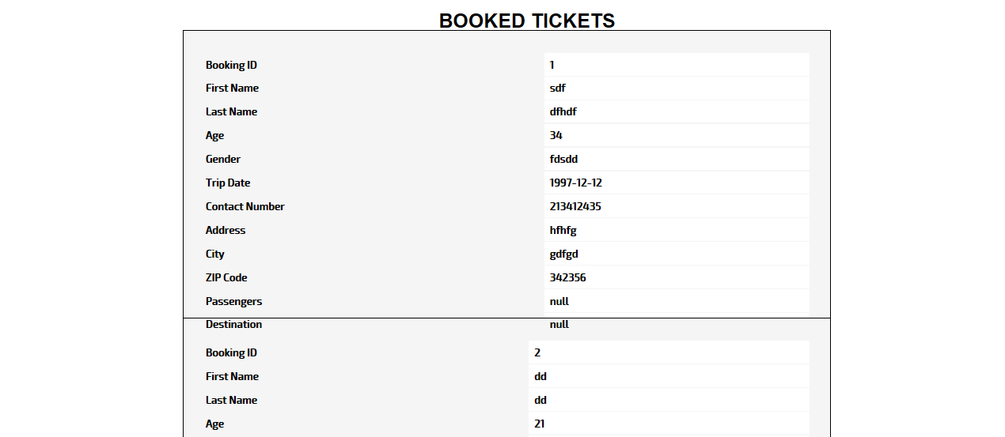

After user had successfully logged in, it will redirect you to

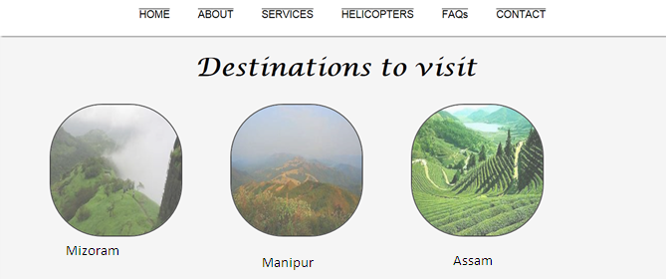

After selecting any one destination, it will redirect you to

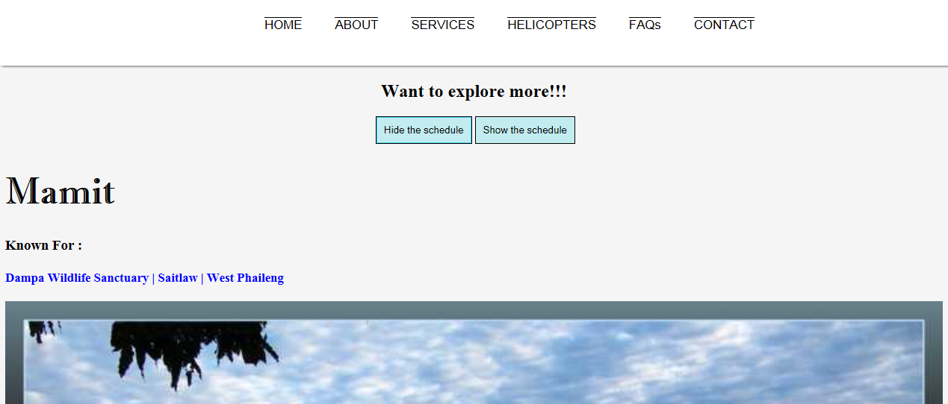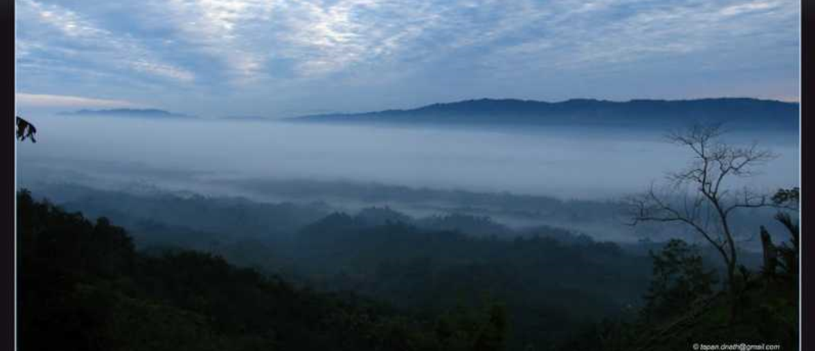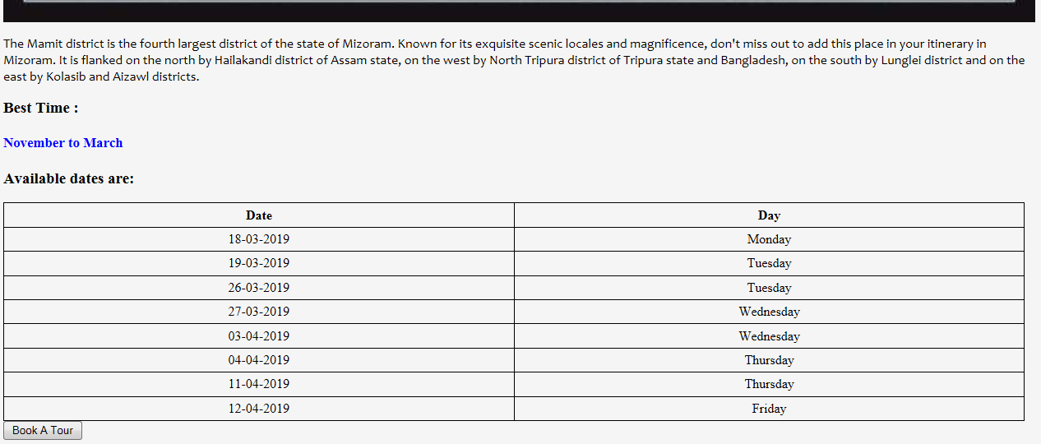

When you click at “Book A Tour”, it will redirect you to

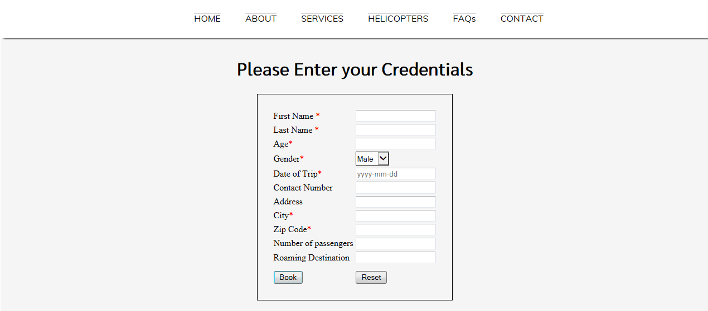

Fill the details properly.

When you click at “Book”, it will redirect you to

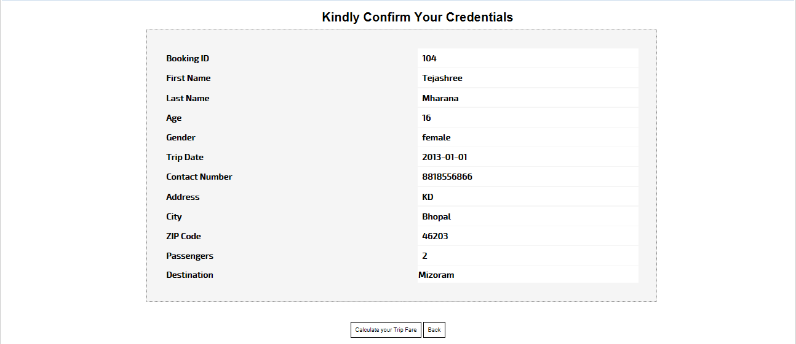

When you click at “Calculate Your Trip Here”, it will redirect you to

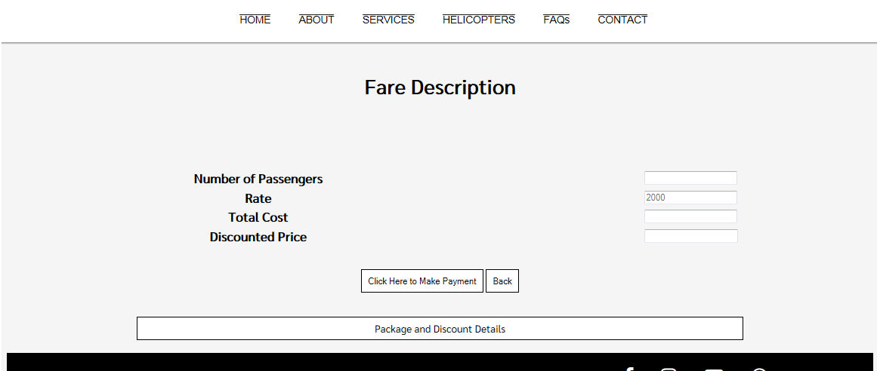

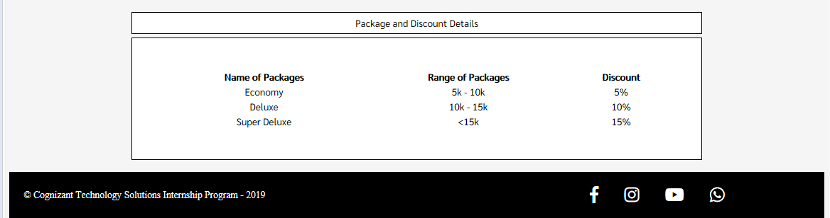

When you click at “Click here to Make Payment”, it will redirect you to

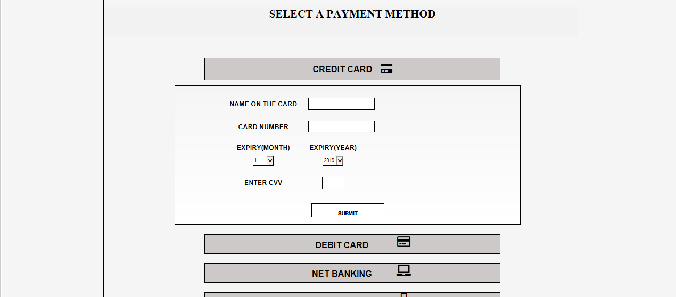

When you click at “Submit”, it will redirect you to

